**Senior Design 1**

MDAS.ai Drive-By-Wire Using V2X for Enhanced Safety

**System Test Plan**

**Version 1 / 2 November 2018**

**Fall 2018**

Team #7 - Classified:

Athanasios Argyris, Kayleigh James, Sarah Overbeck, Joshua Quejadas

Contact Information: [soverbec@umich.edu](mailto:soverbec@umich.edu) or [aargyris@umich.edu](mailto:aargyris@umich.edu) or [jamesmk@umich.edu](mailto:jamesmk@umich.edu)

Advisor: Dr. Mike Putty

**Table of Contents**

|  |  |  |
| --- | --- | --- |
| **Section** | **Title** | **Page** |
| 1. | Introduction | 2 |
| 1.1 | Purpose | 2 |
| 1.2 | Objectives | 2 |
| 1.3 | Scope | 2 |
| 1.4 | Test Case Definition | 3 |
| 1.5 | Test Data Analysis Criteria | 17 |
| 2.0 | Execution Plan | 20 |
| 3.0 | Test Schedule | 20 |
| 4.0 | References | 20 |

**1. Introduction**

**1.1 Purpose**

The purpose of this document is to describe the system test plan for MDAS.ai Drive-By-Wire Using V2X for Enhanced Safety. The test plan will outline the procedures for test planning, test execution, and reporting of test results.

**1.2 Objectives**

The system test will evaluate all aspects of the functional and performance requirements for the DbW system and major subsystems. The objective of the system test is to discern whether the system and it high-level components meet the requirements and constraints defined in the requirements specification. The test plan defines the tests that will evaluate system and subsystem performance in a quantitative and qualitative manner. Each test case definition will outline prescribed test cases for each system module with procedures intended to produce analyzable results that will concur with requirement specifications. The test report will summarize the analysis of raw data collected during the overall system test and illustrate to what extent each component under test met requirements.

**1.3 Scope of the Test Plan**

The test plan will be covering a variety of test cases in order to validate that the entire system meets the requirements defined in the Requirements Specification document. The system will be tested in a lab setting as that is the environment in which it must operate; this was also outlined in the Requirements Specification document.

We have six test cases that will be covered in this document. These six test cases will allow us to validate that all of our performance requirements have been meet by the system. The six test cases are as follows:

1. Normal Driving Conditions - Static Test - No message of a pedestrian in the crosswalk from the RSU, no lack of messages being sent from the joystick, no lack of control messages between modules being sent, and no input torque applied to the steering wheel by the driver. Vehicle in the lab and up on jacks.
2. Normal Driving Conditions - Road Test - No message of a pedestrian in the crosswalk from the RSU, no lack of messages being sent from the joystick, no lack of control messages between modules being sent, and no input torque applied to the steering wheel by the driver. Vehicle off of jacks, out of the lab, and on the road.
3. Pedestrian in the Crosswalk - Message sent from the RSU to the vehicle stating that there is a pedestrian in the crosswalk ahead.
4. No Control Messages Being Sent - Lack of messages being sent by any or all of the modules.
5. Wheel Turn by the Driver - The driver turns the steering wheel, disengaging DbW mode.
6. Emergency Stop - The emergency stop button is pressed, causing the vehicle to enter safe mode.

The test cases will all be performed independently. In each test case, data will be collected and an assessment will be performed to decide whether or not the requirements related to that test case has been met. The data will be recorded in an Excel spreadsheet. Each test case will have a separate sheet in order to organize our findings. The following sections contain all of the detailed test procedures and assessment criteria for each of our test cases.

**1.4 Test Case Definition**

**1.4.1 Test Case 1:** Emergency Stop - Testing of the E-Stop to make sure DbW & motor controller does not engage.

Traces to Requirements:

* Throttle requirements: 3.2.1, 3.2.2, 3.2.3, 3.2.5, 3.2.6, 3.2.7
* Steering requirements: 3.3.3
* Brake requirements: 3.4.4
* Power requirements: 3.6.1, 3.6.2
* Timing requirements: 3.7.1,3.7.2

**1. Test Case Description:** Our first test case that will be performed is the test of the emergency stop functionality. Since we are working on a full sized vehicle, we must be extremely cautious and have safety as our top priority while testing. The Emergency Stop is the fundamental failsafe in the event of a vehicle or system malfunction so this must best tested first in order to ensure that the remainder of the test cases can be performed in a safe manner.

Test Case Figure:

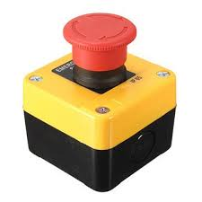

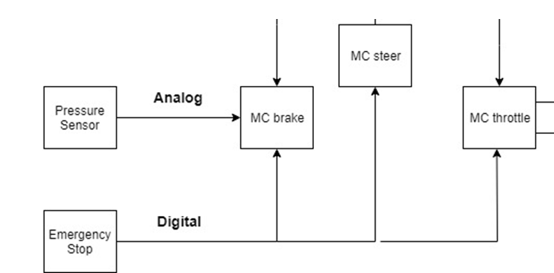

Figure 1.4.1 - Emergency Stop Button and Module Connections

|  |  |
| --- | --- |
| **E-Stop Test Case** | |
| Voltage measurement  (V) | Voltage in Volts  Solenoid On/Off signal voltage (20V if on) |
| Voltage measurement  (V) | Have someone depress the accelerator pedal and measure the voltage from the throttle position sensor (throttle pedal) that is fed into the motor controller. (1.2V & .6V if no force is applied.) |
| Time  (s) | Response time for the vehicle to apply full brake on jacks. |

**2. Test Environment and Conditions:** The system will be developed in a laboratory environment during this project. It will not be exposed to significant temperature changes, vibration, noise, or impact.

**3. Input Data Set:**If the E-Stop is not pressed, the input data set will be 20V being applied to the solenoid analog signal input to enable the passthrough 48V to the motor controller. We input voltage to the motor controller, so that it will operate. Without the 48V supply, the motor controller will not be powered.

**4. Expected data values and results:** Expected data types are outlined in the table above. We expect the results from this test case to indicate that the system meets all relevant requirements. We should see 20V across the solenoid leads when E-Stop is not engaged and ~0V when it is. We also expect that the brake actuator be depressed within 2-3 seconds. Lastly, we should see 1.2V and 0.6V across the two input signals to the motor controller indicating the motor’s steady state.

**5. Test Procedure:** The test below is outlined in a way such that we can test the performance requirement for all the modules E-stop operation mode. It will consist of the following components: Brake, Throttle, Steering module.

* **Test Initialization**:

1. Unplug the vehicle from charging port.
2. Put the vehicle on jacks
3. Put the vehicle in gear and apply manual throttle to ensure it is in working order

* **Test Steps:** Once the vehicle is on initialization step 3, we will do the following tasks:

1. While throttle is still being manually applied, Press the E-Stop.
   1. We want to make sure the E-Stop safety feature is in working order, before moving onto the rest of our tests. It is one of the features that will help us improve the safety of the shuttle. We want the brake board no matter if it is in DbW mode or normal operation mode, to apply full brake. We will do this by pressing the E-Stop and evaluating that our requirements were met.
2. For the first test of the E-Stop press, we will measure the input analog voltage to the motor controller from the throttle pedal and verify that the analog signals are within a valid range to apply 25% throttle. Then, we will verify that the analog signal voltage that controls the solenoid is close to 0V.
   1. The reason why this step is important, is to verify that the analog signals coming out of our pedal are within a valid operation range. Next, we have to verify that the solenoid providing 48V to the motor controller is off. The safest way to do this, is to listen for a click and measure the analog signal voltage that opens/closes the solenoid. WE WILL NOT MEASURE DIRECTLY ACROSS THE SOLENOID INPUT/OUTPUT.
   2. Once we’ve verified that the pedal output voltages are within an opertable range, we can double check that the relay is off. We will do this one time to check the integrity that is functioning as designed.
3. As the E-Stop is pressed, we will use a stopwatch to measure the time it takes for the spinning wheels to stop.
   1. We needed to record the time it takes for the wheels to fully stop after the E-Stop is pressed. Our requirements document specifies that our full stop time should be 2 to 3 seconds for a safe (emergency) stop. Given that this is in seconds, we will be able to quantify this with a stopwatch, even with human reaction time. We will do this by doing a sample of 20 runs and averaging the time that we record to get a more accurate value.
4. Once we have these feature working, we will plug in the joystick and validate that no other modules are responding to inputs while the E-Stop is pressed.
   1. We need this to validate the boards are actually in safe mode. Using a CAN bus sniffer tool, we will validate that the messages to the modules are on the bus and that the boards are not responsive.

* **Test Data Log:**Using an Excel spreadsheet, we will manually log the values and perform computations with the built in Excel functions. The sampling interval will be everytime we perform the test for part 3, and once for the other parts. The data types we will be focusing on are voltage measurements and time.
* **Anomaly Report:**  We will log the average for which we found among all our data and depending on the severity we will report and modify out requirement specification. If the discrepancy seems to be the normal operation for the vehicle (e.g. Stopping time actually take 5 seconds instead of 2 seconds and it is a mechanical hold back), then we will have to log this and adjust our requirement specification document.
* **Suspension Criteria and Resumption Requirements:** If our software is not working at all and the E-Stop does not cut the voltage for the motor controller, we will postpone further testing to investigate and fix the issue. Also, if the modules are still entering DbW mode, and not actuating the brake to full stop with the E-Stop engaged, then we cannot continue on with the rest of our tests. As, the vehicle would not have the safety for going on the road. Thus, this issue would have to be resolved before testing would resume.
* **Test Termination**: Test will be terminated by disengaging the E-Stop button and cycling the power of the vehicle. At this time, the vehicle will be in manual operation until DbW is re-engaged. If test is performed correctly, all steps described above will produce proper voltage values. There should not be any possibility of tainted data.
* **Test Data Log Format:** Data for this test will be discrete voltage values that match the states of each device. Voltages supplied to each module should match those outlined in the requirements specification. (3.2.3) This data will be displayed in a table.Error analysis will determine whether the measured time to fully apply the brakes falls within requirements.

**1.4.2 Test Case 2** Normal Driving Conditions - Static Test

Traces to Requirements:

* Throttle requirements: 3.2.1, 3.2.2, 3.2.5
* Steering requirements: 3.3.1
* Brake requirements: 3.4.1, 3.4.2, 3.4.5, 3.4.6
* Joystick requirements: 3.5.1, 3.5.2
* Power requirements: 3.6.1, 3.6.2
* Timing requirements: 3.7.1,3.7.2

**1. Test Case Description:** The purpose of this case is to test that the behavior of the vehicle is as desired which will indicate that correct messages are being sent at the appropriate frequency. The MDAS.ai vehicle will be placed on jacks in order to ensure control of the vehicle and that the test will be safe especially in the event of a malfunction. This test case will determine whether the system behaves as desired under ideal conditions. This means that the following criteria are true:

* No message of a pedestrian in the crosswalk from the RSU
* No lack of messages being sent from the joystick
* No lack of control messages between modules being sent
* E-Stop will not be pressed
* No input torque applied to the steering wheel by the driver

The vehicle will be operated by the joystick with all of the above conditions being met.

Test Case Figure:

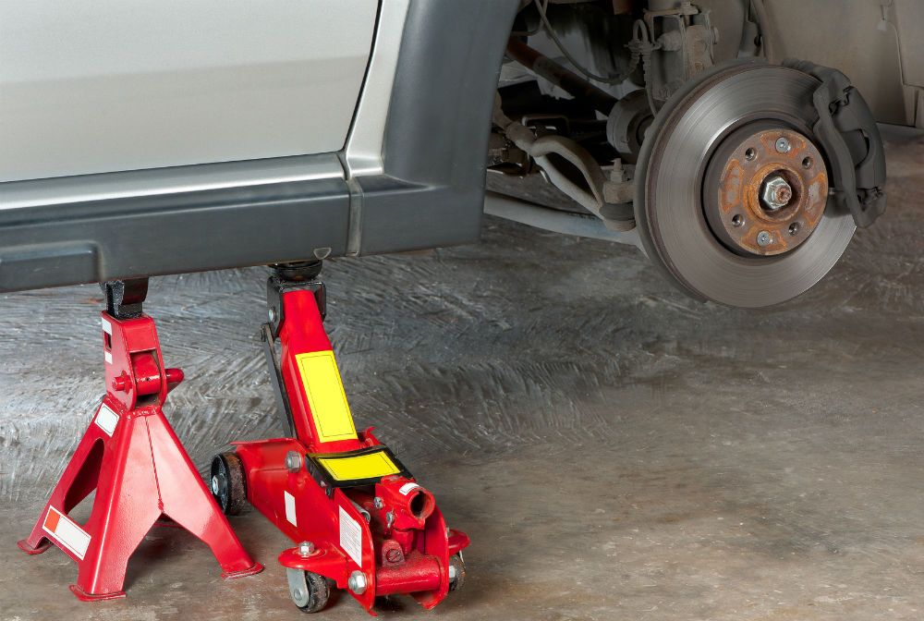

|  |  |
| --- | --- |
| **Static Test Case** | |
| Vehicle Operation | Vehicle accelerates, brakes, and turns given commands from the joystick controller. |
| Time | Latency of command verses actuation (Response time) |

**2. Test Environment and Conditions:** The system will be developed in a laboratory environment during this project. It will not be exposed to significant temperature changes, vibration, noise, or impact.

**3. Input Data Set:** The input data set will be signals sent by the joystick which will be operated by a tester.

**4. Expected data values and results:**Expected data is vehicle behavior. Input through the joystick should produce specific effects in each of the other modules. Response time will be measured quantitatively with a stopwatch while actuation is executed.

**5. Test Procedure:**

* **Test Initialization**:

1. Unplug the vehicle from charging port.
2. Put the vehicle on jacks for the static test.
3. Turn the vehicle on.

* **Test Steps:** Once the vehicle is on initialization step 3, we will do the following tasks:

1. Check Steering (left/right steering via joystick)
2. Check Throttle (Apply more or less throttle via joystick)
3. Check Brake (Apply more or less brake via joystick)

* **Test Data Log:**An Excel spreadsheet will contain the response times of the modules to commands input by the joystick. Analysis of the times will indicate whether transmission and execution time meets requirements. We must also log behaviors of the vehicle to ensure they match joystick commands.
* **Anomaly Report:** An anomaly occurs when joystick input does not match vehicle output or the vehicle does not respond at all.
* **Suspension Criteria and Resumption Requirements:** If the joystick input does not produce the expected behaviour or no response is observed, then testing is suspended to resolve the issue. We will use a USB-to-CAN device to determine if all of the modules are sending and receiving messages as well as ensuring that all connections are in place.
* **Test Termination**:The test will be terminated if analysis as indicated above produces no viable solutions.
* **Test Data Log Format** A table with measured times will be the main data log. Multiple rounds will be completed and the average of the times will be determined. Vehicle behavior is based on observation and will be qualitatively summarized.

**1.4.3 Test Case 3** Normal Driving Conditions - Road Test

Traces to Requirements:

* Throttle requirements: 3.2.1, 3.2.2, 3.2.5
* Steering requirements: 3.3.1
* Brake requirements: 3.4.1, 3.4.2, 3.4.5, 3.4.6
* Joystick requirements: 3.5.1, 3.5.2
* Power requirements: 3.6.1, 3.6.2
* Timing requirements: 3.7.1,3.7.2

**1. Test Case Description:** The purpose of this test case is to test normal operating behavior of all modules. The vehicle will be driven manually to a closed section of road on campus. This test case will reaffirm system operation and that it behaves as desired under ideal conditions: flat, dry pavement. The following criteria are still true:

* No message of a pedestrian in the crosswalk from the RSU
* No lack of messages being sent from the joystick
* No lack of control messages between modules being sent
* E-Stop will not be pressed
* No input torque applied to the steering wheel by the driver

The vehicle will be operated by the joystick with all of the above conditions being met.

Test Case Figure

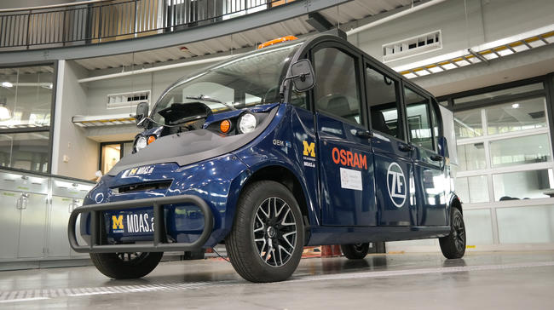 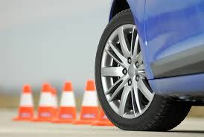

|  |  |
| --- | --- |
| **Road Test** | |
| Stopping distance (ft) | Vehicle should stop within 17-20ft |
| Vehicle behavior | Vehicle accelerates, brakes, and turns given commands from the joystick controller. |

**2. Test Environment and Conditions:** This test is outside and running on a road, but will still be considered as developed in a laboratory environment during this project. It will not be exposed to significant temperature changes, vibration, noise, or impact. Road conditions will be flat, dry pavement, no potholes and no precipitation.

**3. Input Data Set:** The input data set will be signals sent by the joystick which will be operated by a tester.

**4. Expected data values and results:** Expected data is vehicle behavior. Input through the joystick should produce specific effects in each of the other modules. Stopping distance will be measured with the vehicle at 15mph.

**5. Test Procedure:**

* **Test Initialization**:

1. Unplug the vehicle from charging port.
2. Turn the vehicle on.
3. Place on strip of road.

* **Test Steps:** Once the vehicle is on initialization step 4, we will do the following tasks:

1. Check Steering (left/right steering via joystick)
2. Check Throttle (Apply more or less throttle via joystick)
3. Check Brake (Apply more or less brake via joystick) and record stopping distance

* **Test Data Log:**An Excel spreadsheet will contain the stopping distances of the vehicle Analysis of the average distance will indicate whether the braking of the vehicle is within requirements and is safe. We must also log behaviors of the vehicle to ensure they match joystick commands.
* **Anomaly Report:** An anomaly occurs when joystick input does not match vehicle output or the vehicle does not respond at all. Also, if the vehicle does not brake at all or the stopping distance is far too great it is not safe to continue testing.
* **Suspension Criteria and Resumption Requirements:** If the joystick input does not produce the expected behaviour or no response is observed, then testing is suspended to resolve the issue. We will use a USB-to-CAN device to determine if all of the modules are sending and receiving messages as well as ensuring that all connections are in place. If stopping distance is much longer than originally included, the requirement may need to be re-analyzed and altered to accommodate physical limitations.
* **Test Termination**:The test will be terminated if behavior issues cannot be corrected by initial examination. This would especially be if the stopping distance is much greater than the requirement specification. Alterations may need to be made to the requirement.
* **Test Data Log Format** A table with measured stopping distances will be the main data log. Multiple rounds will be completed and the average will be determined. Vehicle behavior is based on observation and will be qualitatively summarized.

**1.4.4 Test Case 4** Pedestrian in Crosswalk

Traces to Requirements:

* DSRC requirements: 3.1.x
* Throttle requirements: 3.2.x
* Steering requirements: 3.3.x
* Brake requirements: 3.4.1-2, 3.4.4-8
* Power requirements: 3.6.1, 3.6.2
* Timing requirements: 3.7.1,3.7.2,3.7.3

**1. Test Case Description:** The purpose of this test case is to test operating behavior of the DSRC radio and the onboard module. This test case will ensure that the system behaves as desired under ideal conditions. This means that the following criteria are true:

* A message of a pedestrian in the crosswalk is sent from the RSU
* No lack of messages being sent from the joystick
* No lack of control messages between modules being sent
* E-Stop will not be pressed
* No input torque applied to the steering wheel by the driver or pressure on brake pedal

The vehicle will be operated by the joystick with all of the above conditions being met.

Test Case Figure

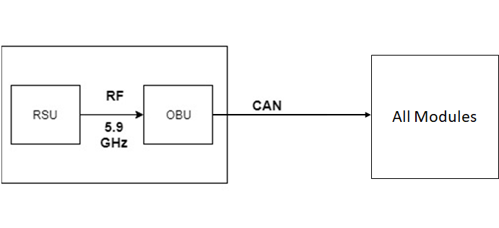

|  |  |
| --- | --- |
| **DSRC Test** | |
| CAN Message | An USB-to-CAN will be used to read messages sent. |
| Distance (ft) | Stable and reliable range of DSRC |
| Vehicle Operation  (s) | Vehicle halts upon receiving the correct DSRC signal within normal brake stop time (2-3 seconds) |

**2. Test Environment and Conditions:** The system will be developed in a laboratory environment during this project. It will not be exposed to significant temperature changes, vibration, noise, or impact.

**3. Input Data Set:** The DSRC module of the system will be tested in varying ranges with a maximum at 100 feet. A signal will be sent by RSU to the OBU indicating a pedestrian in a “crosswalk”. The DSRC message should be converted into a CAN message that, when transmitted, will alter the states of the modules causing the vehicle to enter safe mode.

**4. Expected data values and results:** The expected data is a CAN message signaling the vehicle to slow to a stop based on the radio’s position. The vehicle should stay in front of the pedestrian walkway within the prescribed stoppage time, after which normal DbW operation will resume.

**5. Test Procedure:**

* **Test Initialization**:

1. Setup the USB-to-CAN
2. Setup the DSRC radio.
3. Unplug the vehicle from charging port.
4. Turn the vehicle on.
5. Have the vehicle on road (Test Case 3)

* **Test Steps:** Once the vehicle is on initialization step 5, we will do the following task:

1. Check RSU and OBU are within range of each other
2. Check RSU and OBU can communicate to each other.
3. Check the vehicle stops when “pedestrian in crosswalk” is sent.

* **Test Data Log:**Data is collected using a USB-to-CAN device. The CAN message generated when OBU is signaled by RSU is logged onto Excel. The DSRC distance will also be noted as well as the time it takes for the vehicle to stop after reception of the original DSRC signal.
* **Anomaly Report:** We will log all the generated messages (multiple copies of the same message) by the OBU onto a separate sheet. An anomaly occurs when the measured CAN message differs from expected CAN message. Also, in the event of a DSRC radio malfunction such as low RSSI or high noise floor in the environment will have to be addressed immediately.
* **Suspension Criteria and Resumption Requirements:** Testing is suspended if the CAN message consistently differs from the expected CAN message. Also, if the RSU and OBU fails to communicate with each other, testing will be suspended until the issues can be resolved.
* **Test Termination**:The test is terminated after incorrect CAN messages or if modules do not respond appropriately whenever the DSRC communicates with the vehicle.
* **Test Data Log Format**: The data collected is a list of generated CAN messages by the OBU at different ranges. These data will indicate if the DSRC radio is able to consistently communicate with the vehicle and generate the correct CAN message. A table will be used to log all the raw data. Data is summarized through success rates at varying ranges. Error analysis will determine if the expected message is transmitted consistently.

**1.4.5 Test Case 5** No Control Messages Being Sent

Traces to Requirements:

* Throttle requirements: 3.2.4
* Steering requirements: 3.3.2
* Brake requirements: 3.4.3
* Timing requirements: 3.7.1-3

**1. Test Case Description:** The purpose of this case is to test if the vehicle appropriately disengages dBW mode when at least 3 consecutive messages fail to send or are corrupted. This test case will ensure that the system behaves as desired under ideal conditions and will act appropriately if CAN subsystem fails. This means that the following criteria are true:

* No message of a pedestrian in the crosswalk from the RSU
* No messages being sent from the joystick or improper signal is generated
* No control messages sent between modules via CAN
* E-Stop will not be pressed

Test Case Figure 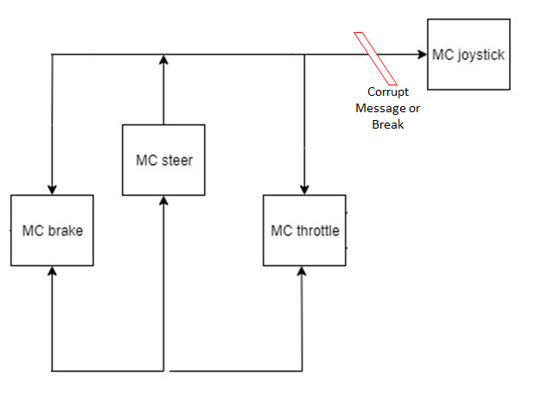

|  |  |
| --- | --- |
| No Control Messages | |
| CAN Message | 3 Consecutive messages not sent through CAN bus. |
| Time | DbW disengages within 200-500ms |

**2. Test Environment and Conditions:** The system will be developed in a laboratory environment during this project. It will not be exposed to significant temperature changes, vibration, noise, or impact.

**3. Input Data Set:** The vehicle will be initially controlled as listed in test case 2. Control will be halted suddenly by disconnecting the joystick or another CAN line to simulate messages failing to consecutively send.

**4. Expected data values and results:** Expected data values are several iterations of purposely dropping messages. The time it takes from ceased control messages to dBW disengaging will be measured and should be within 200-500ms.

**5. Test Procedure:**

* **Test Initialization**:

1. Unplug the vehicle from charging port.
2. Turn the vehicle on.
3. Put vehicle on jacks for a static test.

* **Test Steps:** Once the vehicle is on initialization step 3, we will do the following tasks:

1. Send control signals using joystick.
   1. Before completing this test, normal operating conditions must be established of the DbW system. This will be a shorter version of the second test case so that every time the joystick is disconnected there are no other issues that arise within the system.
2. Stop sending signals and start timing until dBW disengages
3. Repeat a few times to make sure DbW always disengages and then can be re-engaged one connections are re-established and vehicle power is cycled.

* **Test Data Log:**The data log will consists of the turnaround time from ending the control signal to the disengaging of the dBW.
* **Anomaly Report:**  If the vehicle takes too long to respond (more than 500 milliseconds) or if DbW does not disengage at all, then there exists an issue with the communication bus. This also indicates that the car will not safely stop DbW control in the event that the system malfunctions.
* **Suspension Criteria and Resumption Requirements***:* Testing will be suspended if the vehicle fails to disengage at all. The issue will be analyzed to see if an extra connection exists or other issue which rerouted communication, and will fixed before testing can resume. Reversion to test case 2 may be necessary to reestablish that normal conditions are met.
* **Test Termination**:The test is terminated once several iterations have been completed. The test is successful if the data show consistent turnaround time. Possibility of tainted data should not be possible.
* **Test Data Log Format:** A table specifying the turnaround time.

**1.4.6 Test Case 6** Steering Input Torque Override

Traces to Requirements:

* Steering requirements: 3.3.4
* Timing requirements: 3.7.1-3

**1. Test Case Description:** The purpose of this case is to test that the vehicle disengages dBW mode in the event the wheel input torque exceeds ±7Nm and control reverts back to manual. This test case will ensure that the system behaves as desired under ideal conditions. This means that the following criteria are true:

* No message of a pedestrian in the crosswalk from the RSU
* No lack of messages being sent from the joystick
* No lack of control messages between modules being sent
* E-Stop will not be pressed

Test Case Figure

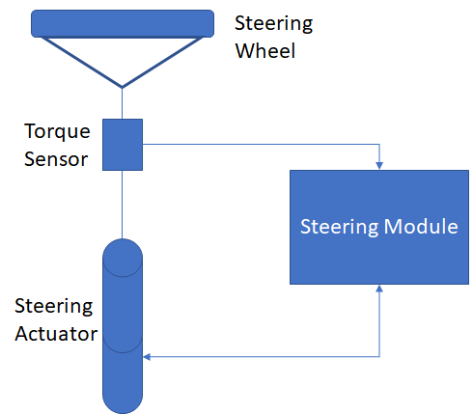

|  |  |
| --- | --- |
| **Steering Input Torque Override** | |
| Input torque measurement (Nm) | Message sent by the steering actuator converted into torque. Can be viewed on CAN bus |
| Time (s) | Response time for the vehicle to disengage DbW |

**2. Test Environment and Conditions:** The system will be developed in a laboratory environment during this project. It will not be exposed to significant temperature changes, vibration, noise, or impact.

**3. Input Data Set:** The input steering torque has to remain under a certain threshold to indicate it is not being manually overridden. Once this threshold of ±7Nm is exceeded, the vehicle must reliably disengage DbW mode.

**4. Expected data values and results:**The expected data types is listed above. The vehicle is expected to disengage DbW mode past a certain threshold.

**5. Test Procedure:**

* **Test Initialization**:

1. Unplug the vehicle from charging port.
2. Put the vehicle on jacks for a static test.
3. Turn the vehicle on.
4. Have one tester using the joystick to control the vehicle.
5. Have tester to readily turn the steering.

* **Test Steps:** Once the vehicle is on initialization step 5, we will do the following tasks:

1. Control the vehicle using the joystick to simulate autonomy.
2. The tester will turn the steering wheel to trigger the steering module to disengage DbW.

* **Test Data Log:**The input torque sensor outputs will be logged via a USB-to-CAN device and if the vehicle successfully disengaged dBw mode once it exceeds ±7Nm. This will be iterated several times to create an average.
* **Anomaly Report:**  One crucial possible anomaly is the steering actuator exceeds ±7Nm torque threshold and DbW does not disengage. Testing cannot be continued without this feature because it is the object of the test. We will report this issue and proceed to fix it.
* **Suspension Criteria and Resumption Requirements:** The most crucial error requiring test suspension is if steering actuator exceeds the specified torque threshold and fails to disengage DbW mode. In order to restart the test, the sensor output and the CAN message must be analyzed to determine whether both are accurate. Scaling may need to be adjusted to correct torque reading.
* **Test Termination**:The test is terminated if the steering actuator exceeds ±7Nm torque threshold and DbW does not disengage. This issue must be fixed and if it cannot, testing must cease.
* **Test Data Log Format***:*  For each test iteration, the input torque sensor outputs will be logged when external torque is applied to the steering wheel. Time it takes to disengage DbW will also be recorded.

**1.5. Test Data Analysis Criteria**

**1.5.1 Test Case 1:** E-Stop Case

**(1) Define Criteria for Successful Test Completion**

The emergency stop should activate and deploy within 2 to 3 seconds.

Acceptable values for response time are as follows:

Minimum value of 2s

Maximum value of 3s

Mean of 2.5s

Possible anomaly is the brakes take 5 seconds to actuate. This is treated by checking the mechanical parts with a different team.

**Test Case Criteria:** actuation time measurements mean error rate (requirement 3.4.8)

**(2) Defect Severity Definitions:**

|  |  |  |
| --- | --- | --- |
| **Data Type** | *Mean Range Error 2sec<t< 3sec* | |
| Actuation Time | > 90% | Excellent |
| Actuation Time | [85% - 90%) | Good |
| Actuation Time | [80% - 85%) | Minimum Satisfactory |
| Actuation Time | < 80% | Failure |

**1.5.2 Test Case 2:** Static Test

**(1) Define Criteria for Successful Test Completion**

Vehicle operation will match joystick inputs.

Latency times (response time)

Average time of 100ms

Possible anomaly is modules do not respond to joystick commands correctly.

**Test Case Criteria:** Mean response time ≤ 100ms

**(2) Defect Severity Definitions:**

|  |  |  |
| --- | --- | --- |
| **Data Type** | *Mean Range Error <100ms* | |
| Response Time | > 90% | Excellent |
| Response Time | [85% - 90%) | Good |
| Response Time | [80% - 85%) | Minimum Satisfactory |
| Response Time | < 80% | Failure |

**1.5.3 Test Case 3:**  Road Test

**(1) Define Criteria for Successful Test Completion**

Stopping distance of the vehicle should be between 17 and 20 feet

Minimum distance = 17ft

Maximum distance = 20ft

Average = 18.5 ft

Vehicle behavior will match joystick inputs

Possible anomaly is when modules do not respond correctly to joystick inputs

**Test Case Criteria:** stopping distance measurements mean error rate < 1.5 ft

**(2) Defect Severity Definitions:**

|  |  |  |
| --- | --- | --- |
| **Data Type** | *Mean Stopping Distance Error* < 1.5ft | |
| Stopping Distance | > 90% | Excellent |
| Stopping Distance | [85% - 90%) | Good |
| Stopping Distance | [80% - 85%) | Minimum Satisfactory |
| Stopping Distance | < 80% | Failure |

**1.5.4 Test Case 4:**  Pedestrian in Crosswalk

**(1) Define Criteria for Successful Test Completion**

Distance for reception of DSRC signal

Maximum distance = 100ft

Vehicle stops upon receipt of DSRC signal within 2-3 seconds

Minimum time = 2sec

Maximum time = 3sec

Mean Time = 2.5sec

Possible anomaly is mis-timing of signal reception and brake actuation start that causes an outlier. Will have several tests to determine if this repeats

**Test Case Criteria:** range measurements mean error rate <0.5s

**(2) Defect Severity Definitions:**

|  |  |  |
| --- | --- | --- |
| **Data Type** | *Mean Range Error <0.5s* | |
| Stopping Time | > 90% | Excellent |
| Stopping Time | [85% - 90%) | Good |
| Stopping Time | [80% - 85%) | Minimum Satisfactory |
| Stopping Time | < 80% | Failure |

**1.5.5 Test Case 5:**  No Control Messages Being Sent

**(1) Define Criteria for Successful Test Completion**

3 Consecutive CAN messages not sent through CAN bus

DbW disengages within 200-500ms

Minimum time: 200ms

Maximum time: 500ms

Mean time: 350ms

Possible anomaly: vehicle takes greater than 500ms to respond. This is a serious error and will require cessation of testing.

**Test Case Criteria:** range measurements mean error rate < 50ms

**(2) Defect Severity Definitions:**

|  |  |  |
| --- | --- | --- |
| **Data Type** | *Mean Range Error <50ms* | |
| Response Time | > 90% | Excellent |
| Response Time | [85% - 90%) | Good |
| Response Time | [80% - 85%) | Minimum Satisfactory |
| Response Time | < 80% | Failure |

**1.5.6 Test Case 6:**  Steering Input Torque Override

**(1) Define Criteria for Successful Test Completion**

Input torque measurement

Range: Exceeds ±7Nm

Response time:

Average disengage time: 100ms

Possible anomaly: Input torque exceeds ±7Nm and does not disengage DbW. Testing cannot be continued if this occurs.

**Test Case Criteria:** response time mean error rate < 10ms

**(2) Defect Severity Definitions:**

|  |  |  |
| --- | --- | --- |
| **Data Type** | Response Time Mean error Rate <10ms | |
| Response Time | > 90% | Excellent |
| Response Time | [85% - 90%) | Good |
| Response Time | [80% - 85%) | Minimum Satisfactory |
| Response Time | < 80% | Failure |

**2. Execution Plan:**

We will be executing our test cases in order of importance of safety, the order can be seen as follows:

1. Emergency Stop
2. No Control Messages Being Sent
3. Wheel Turn by the Driver
4. Normal Driving Conditions - Static Test
5. Normal Driving Conditions - Road Test
6. Pedestrian in the Crosswalk

Our first test case that will be performed is the test of the emergency stop functionality. Since we are working on a full sized vehicle, we must be extremely cautious and have safety as our top priority while testing. The Emergency Stop is the fundamental failsafe in the event of a vehicle or system malfunction so this must best tested first in order to ensure that the remainder of the test cases can be performed in a safe manner.

Following the completion of the emergency stop system test, we will need to perform the test case for when no control messages are being sent. This feature should be the primary mechanism for safety in the event of a communication failure.

Once the test case for no control messages being sent has been completed, we will be testing the vehicle’s safety behavior for when an input torque is applied to the steering wheel by the driver. This is another safety feature that should be the first response in the event that a driver needs to take control of the vehicle. All three of these tests pertain to the safety of the system and thus needed to be tested before the rest of the system’s functionality can be assessed.

After the safety-related test cases have been performed we will be assessing the vehicle’s behavior in normal driving conditions. For the first normal driving conditions test, the vehicle will be placed off of the ground and on jack in order to make sure it is behaving properly before it is lowered off of jacks and driven on a road. Once the team has confirmed that the system passed this test we will be performing a road test to fully assess whether or not our system meets the performance requirements.

Finally, an assessment of the DSRC communication portion of this system will be performed. Since the vehicle can still function safely without communication from the RSU, we decided this was our lest test case that we would cover.

**3. Test Schedule:**

The test plan will be executed following the completion of project build next semester. Currently, we do not have dates for when the build phase will be completed. Upon development of a schedule for next semester, we will create a test schedule and this section will be updated.

**4. References: list any references**

[1] System Requirements Specification

[2] System High Level Design Specification (Yet to be completed)